Group Term Project
Background

RBL BioChemical Corporation (RBL BioChem) is a start-up biochemical firm specializing in the research, development, and production of synthetic biocatalysts. Originally just a research laboratory, RBL BioChem has recently started to expand its operations to include the development and production of the synthetic biocatalysts it researches.

Scientists at RBL BioChem have developed a new synthetic biocatalyst that causes Riesling grapes to become highly susceptible to the botrytis mold. Riesling grapes that are attacked by the mold become very porous, allowing water to evaporate while the sugar remains. The wine resulting from the harvesting and processing of such grapes is highly valued by wine connoisseurs due to its extraordinary complexity. Vineyards that produce Riesling wines could profit greatly from the use of the new biocatalyst, greatly increasing the production of the superior quality botrytised Rieslings. Botrytised Rieslings are very rare and expensive, commanding a substantial increase in market price.

The new synthetic biocatalyst is named Dulcis. The final research and development work is nearing completion and RBL BioChem management is now considering how to best proceed with the actual production and marketing of Dulcis. In order to meet expected demand, they are considering expanding their current production facility.

RBL BioChem has already decided to launch Dulcis. The packaging size of a single unit of Dulcis has also already been determined. Moreover, the firm has identified the particular market segments it wishes to target. For example, currently, Dulcis will only be launched in the United States due to regulatory limitations. Expansion to other markets will be considered at a later date.

Several decisions remain that are not being considered in this analysis. For example, there are a number of different processes available for the production of Dulcis. Moreover, selection of the appropriate distribution channels is an important issue that must be addressed. Finally, from a larger strategic perspective, how does the launch of Dulcis fit in with the other products in RBL BioChem’s portfolio?

Strategic Decisions

RBL BioChem could produce and market the Dulcis product itself. However, its current production facility is limited to 2.5 million units of biocatalyst per year and this may not satisfy entire demand if demand is high. Conversely, the 6 million unit expansion currently under consideration would not be needed if demand is low. Expansion would bring total capacity to 8.5 million units per year and would be completed by the time Dulcis is ready for full production (start of 2017).
RBL BioChem is considering a strategic partnership with a large chemical engineering firm; PuDont has made the following two offers:

- Joint Venture – PuDont will pay for the plant expansion in return for a 60% share of the net profits before tax (sales revenue – total production cost). PuDont would perform all marketing; RBL BioChem would produce Dulcis.

- Royalty Partnership – RBL BioChem licenses Dulcis to PuDont. PuDont would produce (it has enough capacity to meet any realistic demand) and market the new product. RBL BioChem would receive a royalty payment of 3% of sales revenue.

RBL BioChem management believes the particular terms of the two offers may be negotiable and desires information it could use for making counteroffers.

Consultation

RBL BioChem has hired your consulting firm to aid in this strategic decision situation. RBL BioChem seeks clarity of action and eagerly anticipates the delivery of your pilot study.

The following uncertainties were identified through initial meetings with RBL BioChem:
- Demand Growth Rate – The constant rate at which demand for Dulcis will grow each year after its initial release.
- Initial Demand – The initial (year 2017) demand for Dulcis. The firm that markets the product, RBL BioChem or PuDont, is relevant to initial demand. RBL BioChem believes PuDont’s expertise in marketing would enable a significant increase in the initial demand if it were allowed to market Dulcis. It expresses this belief in terms of a multiple, a multiplicative increase in the initial demand that occurs should PuDont market the product. Note that if demand surpasses capacity then the surplus demand and attendant profit is lost.
- PuDont Multiple – The multiplicative increase in initial demand that occurs if PuDont markets Dulcis.
- Plant Construction Cost – The cost to build the new 6 million unit / year production facility.
- Unit Production Cost – The cost to produce one unit of Dulcis.
- Unit Revenue – The revenue received from the sale of one unit of Dulcis.

RBL BioChem experts felt comfortable providing initial assessments on a number of distinctions that characterize the uncertainties faced in this situation. The 10-50-90 (Low-Base-High) points of the distinctions were assessed during the same initial meetings with RBL BioChem and are indicated in the chart below. You are to use the Equal Areas Method (i.e., 0.25/0.50/0.25) for the probability assignments of the Low-Base-High points in your probabilistic analysis.

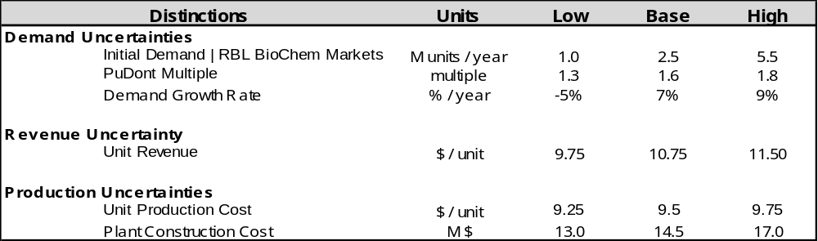

RBL BioChem’s corporate tax rate is 38% for this venture and for planning purposes it expects this rate to remain unchanged. The RBL BioChem accountant your team spoke with made it clear that in any year in which earnings before tax is negative (i.e., the firm suffers a loss), the tax payment for that year is zero and the resulting negative tax is treated as a tax credit, which can then be applied to the next year’s tax payment. Tax credit is kept on the balance sheet and can be applied to subsequent yearly tax payments. (Do not discount tax credit balance.)

RBL BioChem’s management wants your analysis team to use a real discount rate of 8%, due to other investment opportunities the firm typically faces. RBL BioChem’s planning horizon is ten years. Dulcis launches in early 2017 and the firm wishes to consider profit generated by this venture out to year 2026.

A senior member of your team has confirmed that RBL BioChem satisfies the delta property, given the range of profits faced in this situation. She also elicited the firm’s risk tolerance in a separate interview. RBL BioChem’s risk tolerance is $30M.

RBL BioChem requires your team’s assistance with determining the value of collecting additional information. What is the maximum amount of money RBL BioChem should spend on increasing its certainty regarding initial demand for Dulcis? The question has become important because a reputable marketing research firm, Experienced Enterprise Marketing Research Corporation (EEMRC), has offered to conduct a meta-analysis to more accurately estimate initial demand for Dulcis. EEMRC has reported the following information regarding the sensitivity and specificity of its market analysis procedure:

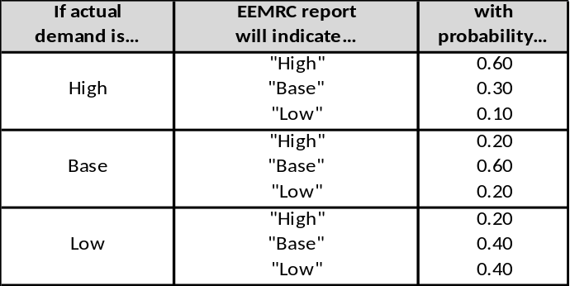

EEMRC has offered its services for the low price of $250,000. Should RBL BioChem hire EEMRC?
Another matter that RBL BioChem leadership has asked for assistance with is the question of additional expenditure of funds with respect to the production of Dulcis. In particular, the Dulcis production team leader has indicated that a promising new chemical processing technique, if proven successful, would drive down unit production cost to approximately $9.25 per unit. RBL BioChem leadership wants to know the value of controlling unit production cost; as an initial estimate, what is the maximum budget it should allocate towards such research?

Deliverables & Timeline

First, your consulting firm must deliver In Progress Review (IPR) slides to RBL BioChem on Tuesday, 31 January 2017. This should be a focused 4-5 slide presentation (no more than 5 slides). The goal of these slides is to develop the Frame of the decision. You will not deliver this presentation; make sure the slides can speak for themselves. Use diagrams and thought products from the Handbook to communicate your point. At a minimum, the slides should include the following:

      - Title Slide
          - Name of your consulting firm (be creative!)
      - Purpose
          - What are you doing?
          - Why?
          - Decision Hierarchy
          - Initial Influence Diagram (for test purchase decision)
      - Identify and Explain Decision Alternatives
      - Discuss Next Steps

Additionally, your consulting firm has promised an extensive written report to RBL BioChem, detailing the full technical results of your decision analysis pilot study. Important insights should be clearly explained; explore the trade space. Additionally, a presentation must be created and delivered. Key recommendations and findings must be packaged and effectively communicated to the firm’s executive committee in a 15 minute PowerPoint slide presentation (assume at least 5 minutes of discussion afterward for a total of 20 minutes). Do not assume decision makers are aware of information from the IPR, this is a comprehensive presentation. Your presentation, at a minimum should include the following:

      - Bottom Line Up Front
      - Frame the decision
          - Issue Sorting- what are the options
          - Decision Hierarchy
          - Influence Diagram (for test purchase decision)
      - Evaluation
        - Deterministic Analysis
          - Spreadsheet Model (.xls template on Blackboard)
          - Deterministic Sensitivity (base NPV bar graph)- base case NPV for each option (1-4)
          - Tornado Diagram (one for each alternative)
        - Probabilistic Analysis
          - Decision Tree (generic for each alternative)- one for each strategy
          - Probabilistic Dominance- CDF charts
          - High-Base-Low Chart
          - Table of Certain Equivalents for each Alternative- CE bar graph for each scenario
      - Appraisal
          - Sensitivity Analysis on Important Parameters- tornadoes
          - Value of Information- how much is EEMRC worth
      - Decision
          - Recommended alternative and focus for next cycle
          - Include a discussion on the trade space (ID what the give and take is for other alternatives)

Your boss has indicated to you that due to the size of this project (there are only six uncertainties), you are not to prune the decision tree as a result of the deterministic analysis (i.e., the tornado diagram).

Your report and presentation should be emailed to Dr. Smith at Christopher.Smith@afit.edu NLT Thursday, 23 February, 2017.

Decision Making

In addition to the deliverables above, each group will serve as the decision making board for another group presenting their work. This will be a graded event, but no preparation is necessary. You are to put yourself in the place of the decision maker and ask questions of the decision group. This is not “stump-the-chump” where you pick apart a group’s briefing in an attempt to earn a higher grade. Your group will be evaluated on quality of discussion after the presentation. Ask questions that explore the trade space. Perhaps be creative with additional information that a decision maker might know, but hasn’t included in the analysis (no changing information already given – I’m thinking about policy or political ramifications to suggested decisions).

